Certificate of Analysis

General properties:
Name：MAL-PEG2000-OH
Molecular Weight： 2000 Dalton
Cat.#： R-1074
Lot.#： 685451
Manufacture Date： 2015.12.09
Date of Analysis： 2015.12.09
Recommended Retest date： 2016.12.09
Stability： 12 months
Storage： -20°C in the dark

Structure

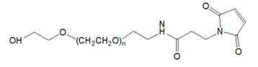

Items | Specification | Results
Appearance | Light yellow/ yellow solid | Light yellow solid
¹H NMR | Identical to the structure | Identical to the structure
Foreign Material | None | None
Substitution | ＞90% | 90%
Report Date: 2015.12.09

This product is for research use only, Not for human or animal use

